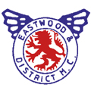

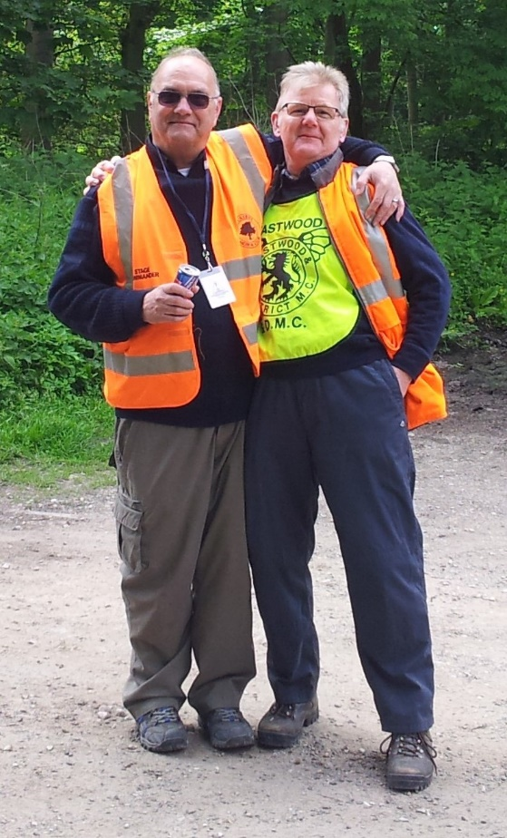

**EASTWOOD AND DISTRICT MOTOR CLUB SCENIC TOUR**

**In memory of RICK HICKMAN and PAUL DAVIS**

Sunday 9th June 2024

**EASTWOOD AND DISTRICT MOTOR CLUB SCENIC TOUR**

**In memory of RICK HICKMAN and PAUL DAVIS**

**Entry Form**

Please complete using BLOCK CAPITALS

Driver’s Name:

......................................................................................

Address:

.....................................................................................

.....................................................................................

.....................................................................................

Post Code:

.....................................................................................

Mobile tel:

……………………………………………………………………………...…

Email Address: .............................................................

Passenger Names:

1. ........................................................................
2. ........................................................................
3. ........................................................................
4. ........................................................................

Motor Club Member? Yes/No (please circle).

Name of Motor Club:

………………………………………………………………………………..

**DECLARATION OF IMDEMNITY**

I declare that to the best of my belief the driver(s) possess a full driving licence and that the vehicle entered is suitable and roadworthy for the event having regard to the course and the speeds which will be reached.

I declare that the vehicle being used is covered by insurance as required by the law which is valid for this event that takes place on roads as defined by the law.

I understand that should I, at any time during this event, be suffering from any disability whether permanent or temporary which is likely to adversely affect my normal control of the vehicle, I may not take part unless I have declared such a disability to MSUK, who have, following such declaration, issued a licence which permits me to enter.

Any application form for an entry which was signed by a person under the age of 18 years must be countersigned by that person’s parent/guardian, whose full names and address must be given.

If I am the Parent/Guardian of the above driver I understand that I shall have the right to be present during any procedure being carried out under the Supplementary Regulations issued for this event and the General Regulations of MSUK.

Note: Where the Parent/Guardian is not present there must be a representative who must produce a written and signed authorisation to act from the Parent/Guardian as appropriate.

I declare that the information given on this form is correct.

Signature of Driver:

........................................................................................................

Date: ...............................................................................................

Please return this entry form before 26th May 2024 with entry fee plus any food costs. Please send it to: sl.gozzard@outlook.com

Please pay by BACS TRANSFER TO: **EASTWOOD DMC LTD,** SORT CODE: **40-19-15,** ACCNT NO.: **52734575,** and mark it with the driver’s surname.

**FOOD ORDER**

Breakfast for the driver and one passenger is included in the entry fee. Please indicate your food choices plus any additional food requests for extra passengers (these need to be paid for in advance).

**Menu**

**Morning breakfast** (tea/coffee included) **No required**

|  |
| --- |
|  |
|  |
|  |

* Bacon Cob
* Sausage Cob
* 2 Egg Cob

**Evening Meal**

|  |
| --- |
|  |
|  |
|  |
|  |

* Pie, Chips and Peas
* Fish, Chips and Peas
* Burger and Chips
* Vegetarian option

**Dessert – a selection of cakes will be available on the day**

For those who would like to book extra Breakfast(s) or Evening Meal(s)

* Breakfast £5
* Evening Meal (main and dessert) £10

|  |  |
| --- | --- |
| **Costs** |  |
| Entry fee | £30.00 |
| Breakfast(s) for extra passenger(s) | £ |
| Evening meal(s) | £ |
| **Total** | **£** |